Sinking of USS Perry in WWII
Story by Lt Frank C. Pogue (Who served aboard the USS Perry)
USS Perry (DMS-17) Stuck Mine and Sinks
At 0500, 13 September 1944, USS Southard (DMS-10), USS Perry and USS Preble (DM-20) was released from anti-sub screening for TG 32.53 to conduct minesweeping operations near Anguar Island. At 0540 the two DMSs streamed S type and Acoustic mine-sweeping gear. With Southard in the lead and Preble acting as a mine destruction unit. At 0845 a floating mine off Cape Ngariois and at 0948 Perry began firing at it but was unable to detonate. Preble later reported that they had exploded it. We continued sweeping without locating any mines, so at 1400 we were secured from General Quarters, an all hand situation, to Condition II in which half of the crew was on watch. This change resulted in my assignment from the steering engine room to Helmsman on the Bridge. It was commonplace for me not to wear my lifejacket, but today the Officer of the Deck, LTJG John Ticusan, Jr. ordered me to don one before relieving the watch. As I took the helm, the sweep commander on Southard signaled a column course change and began his turn. He also announced, "This will be our last run of the day". Moments later there was a loud explosion and the ship lurched, like a bucking bronco, an estimated 10 feet into the air. The binnacle cover flew off the compass grazing my shoulder as it went by and crashed into the bulkhead behind me. It was a good thing that I had a firm grip on the helm or I would have surely been thrown to the deck as nearly everyone else on board were. A few got tossed overboard and another 17 were injured from their falls or from flying debris.
Within seconds all power was off, and Perry lay dead and low in the water listing far to port. An undetected mine had blown the ship nearly in half. The number 1 Fireroom and the five men on watch there were wiped out. Two seamen on deck were critically wounded and they died within 18 hours. Shortly after the Perry was struck, the Captain ordered All Hands to abandon ship. Although most followed the order immediately, some officers and senior enlisted men stayed onboard and went about the task of destroying classified records and equipment.
Most of the lifeboats were either destroyed, badly damaged by the explosion, others were not launched so it was vital to have had a lifejacket when jumping into the ocean. Thinking back about just having left GQ, many of the men were still wearing or had their lifejackets with them which prevented many more deaths.
As I entered the water I found it hard to believe that I was not having a bad dream. As I swam away, I pinched myself a number of times before I realized the situation was real. We had refueled a few days before and at least one of the fuel tanks had ruptured which filled the water with a thick coating oil oil. It was a nasty black color, stunk and burned one's eyes. fortunately for all of us the oil did not catch fire which would have doomed almost all of us. To add to our misery, the Japanese ashore starting shooting at us with their small arms fire which obviously prevented any of us from thinking about swimming to shore.

Part 2 - Rescue
The USS Preble (DM-20) had been trailing the USS Perry to detonate any loosed mines, soon came to our port side to offer assistance in any way possible including sending boats to rescue us in the water and possible tow Perry to safer waters. Boats from USS Southard (DMS-10) and USS Guest (DD-472) soon joined in rescuing us from the water.
I was soon taken to USS Preble along with several others. We were immediately greeted by the ship's Corpsman who handed out small bottles of medicinal brandy. One of the shipmates was gladly accepting the bottles passed on by the non-drinkers and got pretty smashed. We were immediately stripped of our oil-soaked clothes and took a diesel oil sponge bath. When then took several saltwater soap baths before finally getting a freshwater rinse. The crewmembers graciously shared some of their personal clothing with us even though there were no replacements in the ship's stores.
I did manage to save my sheath knife and the contents of my wallet, which contained a beer chit and my very abbreviated diary that was written in tine letters on small pieces of paper. I still have the beer chit and my diary.
We soon discovered that the Preble was completely surrounded by the same kind of mines that had mortally wounded Perry. We wondered if we'd soon be back in the water or worse. The Captain managed to maneuver out of our predicament on to safer waters. We were later transferred to USS Cleveland (CL-55). Other survivors on other ships. and almost all officers went to USS Minneapolis (CA-36).
Russ Noble, a Steinaker shipmate just obtained and shared the USS Tennessee (BB-43), battleship's ship log for 13 September 1944. The deck log for 1600 - 1800 period reads:
"1612 Changed course to 250 degrees T… 1614 Changed speed to 10 knots (085 rpm). 1619 Changed course to 160 degrees T. 1620 Changed speed to 10 knots (85 rpm). 1628 Change course to 115 degrees T. Changed speed to 15 knots (129 rpm). 1630 Changed course to 320 degrees T. 1637 Changed course to 285 degrees T; changed speed to 10 knows (085 rpm). 1650 All engines stopped. 1735 Received 3 stretcher cases and 7 ambulatory from PD 20. They are survivors of the PERRY. Names and rates are as follows: (attached list). 1747 Changed speed to 5 knots (46 rpm). Changed course to 150 degrees T. 1756 Changed speed to 12 knots (103 rpm)."
Signed H.C. Wessling, LT, USNR
According to Frank Pogue, there were 8 deaths as a result of the sinking and 17 Purple Hearts awarded. Although the Health Records went down with the ship, the Yeoman was able to save all the Military Service Records.
The history records on USS Perry reveal: At 1418 while off of Anguar, the USS Perry experienced a violent underwater explosion starboard side amidships, shook the ship. All steam to her main engines were lost and the forward Fireroom was demolished and flooded. Steam and oil sprayed in all directions and the ship took on a 30-degree list to port. The list increased and, at 1420, the commanding officer ordered "abandon ship". With the aid of Preble (DD-345) final attempts to save the vessel were made, but at 1515, all remaining personnel were ordered off. At 1605, Perry capsized. She broke in two at the point of the damage and, at 1607, sank in 40 fathoms of water."
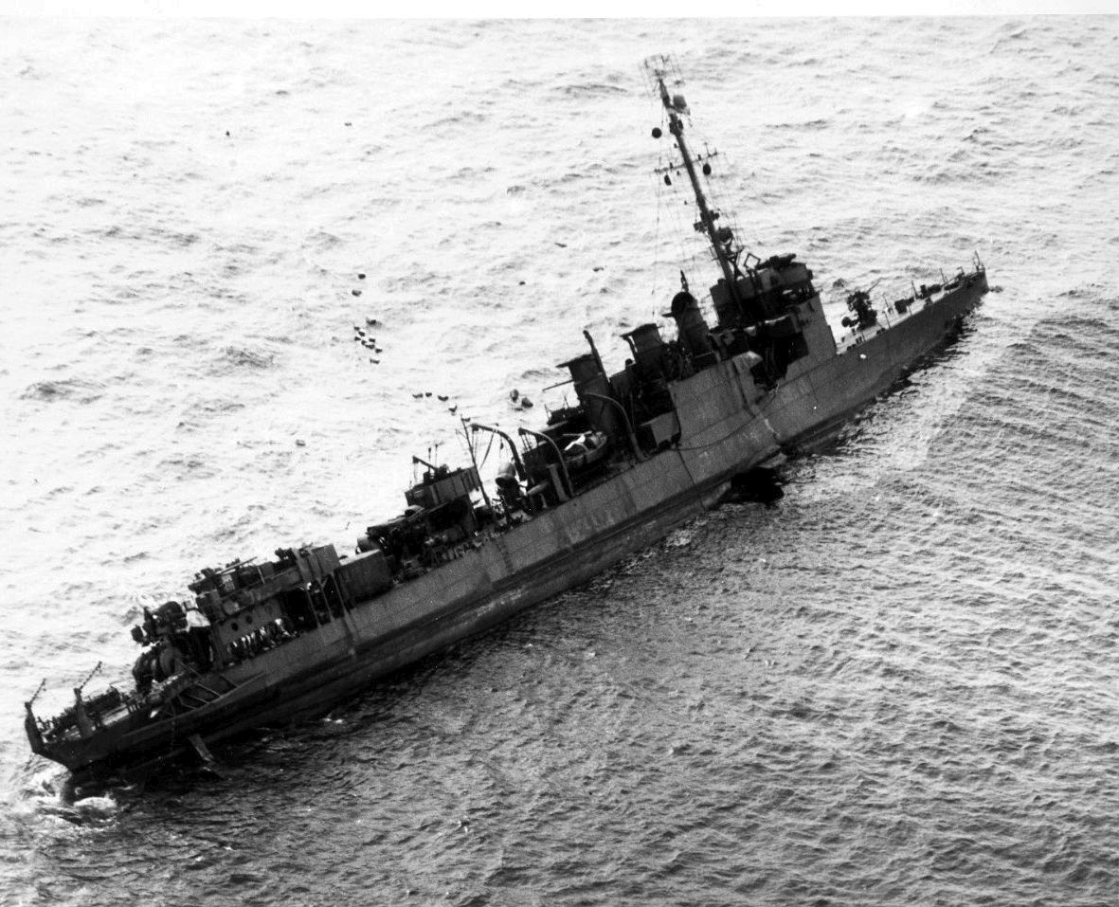
End of Part 2
The Wreck of USS Perry
For decades divers searched for the USS Perry which was sunk by a mine in the Palauan islands two days before the famous WWII assault on Peleliu. Larry Tunks, a survivor of the sinking of Perry hired a search crew that led to the finding of the sunken ship lying in 240 feet of water and about 800 yards off Angaur's southwest coast.
The wreck of the USS Perry was found on 1 May 2000. In December 2003, a diver, Michael Norwood, died while filming on the wreck for the television show, Deep Sea Detectives.
In a Honolulu Star Bulletin, Frank Pogue stated that he believed that the divers should be allowed on the wreck, but "it should be treated the same as a cemetery, with the same respect."
Upon interviewing Frank during the last Steinaker reunion, he stated the ship bent in half (like an L) before sinking. According to the dive team that found the wreck, the ship is laying on its side in an L-shape configuration. They also found an unexploded mine next to the sunk Perry.

